Status update Embedded described video

Project Report Embedded described video

|  |  |
| --- | --- |
| Project Name: | Embedded described video |
| Project duration: | 22.05.2015 - 31.12.2015 |
| Author: | Magne Lunde |
| Last updated: | 21.08.2015 |

MediaLT

Jerikoveien 22

1067 Oslo

Tel: 21538010

E-mail: [info@medialt.no](mailto:info@medialt.no)

www.medialt.no

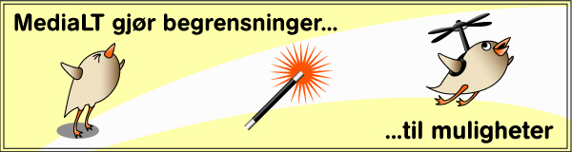

Contents

1 Background 3

2 Status update 3

2.1 Norwegian examples 3

2.2 International examples 4

3 Embedded described video in the series, “Sol, snart seks” 8

4 Guidelines for Embedded described video 9

4.1 First draft guidelines 9

5 Conclusion 10

6 References 12

# Background

Traditionally, audio description (described video) has added an extra voice explaining what is happening in a film or TV programme. Embedded described video removes the need for this extra voice. Instead of adding an extra voice afterwards, audio description (AD) is part of the production process. Adaptations to the dialogue / commentary and sound content enable visually impaired to follow what is happening.

This means that the objective is to be involved right at the start of the production process. Early involvement is important to get good results for Universal Design, as shown by experiences in work with web pages, buildings and recreational areas. The question is whether this is true to the same extent for adaption of TV programmes for visually impaired.

Based on this question we initiated the project Embedded described video in spring 2015 [1]. The main aim of the project is to develop and test methodology for embedded described video in TV programmes. In collaboration with the Norwegian Broadcasting Corporation (NRK), the method is tested in a children’s TV series, “Sol, snart seks”. As a basis for the work, this report gives a status update for work with embedded described video nationally and internationally, and formulates the first draft guidelines for Embedded described video.

# Status update

Audio description of television is an established service in many countries we would naturally compare ourselves to. First in autumn 2014 NRK took the decision to start audio describing [2], and they are now working to put this in place. No other TV channels in Norway offer AD. The situation for AD of television nationally and internationally has been documented in MediaLT’s report Audio Description of Television [3].

## Norwegian examples

Norway’s first production with similarities to what we would today call embedded described video was “Fritt fram for Asgeir”[4], It was done by taking us into the mind of the main character Asgeir, who, as he thinks aloud, describes what is happening.

The good experience from “Fritt fram for Asgeir” led us to initiate the project “Film between the ears” in 2008 [5]. In this project, we investigated which adaptations could be done to the sound picture in the children’s film “Bestevenner” (Best friends), to reduce the need for AD afterwards. In other words, we were not involved in the production process right from the start, but became involved when the sound technicians worked with the film sound. This placed clear limitations on what could be done, but some adaptations were made to the dialogue and other sounds. The response from users was yes to both, that is to say, both to changes in the sound picture and to AD. Experience from this project indicates that it would not be realistic to expect to gain acceptance for embedded described video in all films. This would entail such a large intervention in film material and artistic impression that filmmakers must be willing to think in a completely new way around the process of producing a film. There is therefore a need to research further and discuss openly the consequences of embedded described video in relation to film.

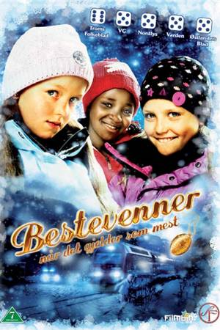

## International examples

Audio description of live TV is not widespread, both England and USA for example have made an exception for live AD in the demands placed on TV companies. Principles used to produce embedded described video may be effective methodologies for producing live AD. In any case, the broadcast of the opening ceremony from Paralympics in 2013 [3] is a good example of how it can be done. The presenters were given training in AD in advance, and extended their descriptions during the live broadcast, largely fulfilling the need visually impaired had for extra description.

A group of people dressed in white with various disabilities at the opening ceremony for Paralympics 2012


AMI [6] in Canada is the only TV company in the world who supply embedded described video, and they were the first to introduce the concept Embedded described video (EDV) [7]. AMI is a television company specializing in accessible TV programmes. They formulated their task in this way: “AMI’s mission is to make accessible media for all Canadians” [6], They wanted to take AD a stage further, by finding out if it was possible to make TV programmes without adding AD afterwards. This was based on their wish to create universally designed TV, which both visually impaired and sighted could watch together.

The first programme produced with embedded described video was the AMI original series “Accessibility in Action” [8], the premiere episode of which was broadcast on AMI-tv in September 2011. The first programme produced with embedded described video that was announced publicly was the AMI original mini-series, “Milestones of Champions – the Journeys of Canada’s Paralympians”, the premiere episode of which was broadcast on AMI-tv in 2012 [9]. Since the early days of “Accessibility in Action” [8], all of AMI-tv’s original programmes have been produced with embedded described video, including: “A Whole New Light,” “AMI This Week,” “Canada in Perspective,” Sports Access,” and more recently “Access Unlimited,” “Blind Sighted” and “Four Senses” [10].

In 2015 AMI-tv carried out a survey of 1200 visually impaired asking which type of AD they wanted: traditional AD or embedded described video. The majority wanted embedded described video. All their programmes are now produced with embedded described video: a demand that also applies to external suppliers who produce programmes for AMI-tv.

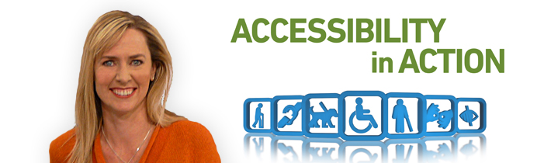

Since May 2014, AMI has been leading a working group to define best practices for embedded described video (EDVBP). We have been given access to several background documents which are not yet publicly available. These documents, and experiences AMI have shared with us, constitute an important basis for this report.

In addition to leading the EDVBP, AMI has created a training course, and has executed presentations and workshops for broadcasters and production companies. Example videos have been produced to demonstrate the difference between traditional AD [11] and embedded described video [12].

In other areas of society, involvement at the start of the process has been shown to be crucial for the achievement of Universal Design. This matches the experiences of AMI in relation to embedded described video. AMI have therefore established a practice where an audio describer is present at the start and participates in the whole production process. In other words, the audio describer is a natural part of the production team. Basically, embedded described video is planned right from the start and the audio describer participates in the creative process of the production. The foundation for the audio describer’s work lies in traditional AD. This competence is important for the audio describer in collaboration with the rest of the team to be able to make TV programmes where the experience for visually impaired is equivalent to that of a sighted person, as far as is possible. In other words, it should not be more difficult for visually impaired to follow events than when traditional AD is used, and the embedded described video should give additional value in that extra description is avoided, and visually impaired and sighted can watch the same version together.

Mariana Lopez at the Anglia Ruskin University has carried out the project “Sound experiments to improve films for blind people” [13]. The work is documented in the scientific article: Perceptual evaluation of an audio film for visually impaired audiences [14]. In this article Lopez writes:

“Although throughout the years, digital technologies have been used to improve the mode of delivery of AD, the notions behind its design have been mostly unchanged despite significant advancements in the field of digital sound production and postproduction. The present paper discusses how sound editing and mixing techniques can be applied to the creation of an alternative to AD called audio film.”

She writes further in the article:

“The prototype for an audio film format described and analysed in this paper helped explore how a story could be told without the need for visual elements or for a description track, by using dialogues, monologues, sound effects, sound processing techniques, musical elements and spatial audio to create a complex yet clear soundtrack.”

Lopez is concerned that AD should be an early part of the production process and not just added at the end. The results of Lopez’s work can be used to see how planning and work with film sound can be used more actively to produce embedded described video. Research should be carried out into how more creative use of sound can add value to embedded described video .

A main differentiator in Lopez’s work and that of AMI is the use of surround sound.

Sound effects and music cues are used to establish action and scene changes. Lopez mentions in particular the need to establish conventions / standards for how visually impaired perceive things with the help of sound, for example, which type of room the person is in (lounge, kitchen, bedroom etc.).

AMI emphasize that embedded described video should be an integral part of the entire work process with film sound in:

* audio capture planning and pre-production
* field and studio audio capture considerations and techniques
* post-production considerations and best practices.

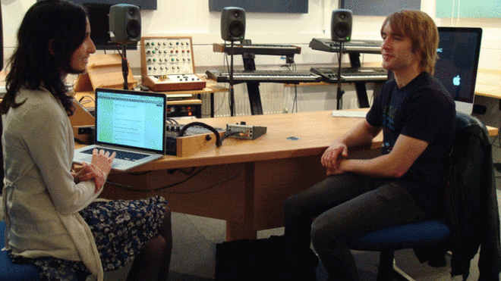

# Embedded described video in the series, “Sol, snart seks”

The original idea was to participate in the planning of the children’s TV series, “Sol, snart seks”, to be present at planning meetings and provide input for work on the manuscript. This report would then also provide input for this work. However the project started a month later than originally planned, and these ideas had to be revised. The series has eight episodes. The script and shoot situations for all the episodes were already in place, but in cooperation with NRK Super we agreed to make a proposal for a manuscript for one episode. We made amendments to the manuscript to produce an episode with embedded described video. The feedback we received from NRK Super was that although they thought the proposed changes were good, they must be subject to review by NRK TV expertise, and there was neither the time nor the resources for this.

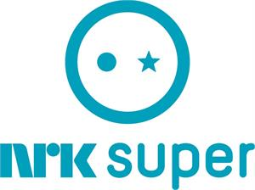

The project group came up with an alternative strategy. The main character (Sol) has a “voice”, first recorded in sound work at the end of the production, and this would form the basis for embedded described video. At the time of writing, we are working on all eight episodes, adding amendments to Sol’s voice and to the film sound. In autumn 2015 NRK will review these proposals and the final version will be completed. Together with this report, the manuscripts will then be given to those responsible for sound editing, as a basis to produce a series with embedded described video.

Our original objective was to make a version which visually impaired and sighted could watch together, but we were involved too late in the process for this to be possible. This led to the decision to make a special version with embedded described video (referred to in the above paragraph).

In spring 2015 NRK started audio subtitling [2], that is to say subtitles are read. The technical solution NRK uses for audio subtitling can also be used to broadcast AD. The special version produced now will be broadcast on the NRK audio subtitles channel.

# Guidelines for Embedded described video

Description is by its nature subjective. Two different audio describers may not describe a TV production or a film in completely the same way. AD can be understood as more an art form than an exact science. There are however certain common guidelines that should be followed. Various guidelines have been proposed internationally, but there is no common standard for how AD should be done. These international guidelines do however share common perspectives. Media Access Australia has attempted to collect these common ideas [15]. AMI and the Canadian Association of Broadcasters (CAB) have developed Described Video Best Practices [16]. These two resources give a good insight into guidelines for traditional AD.

At the time of writing, we are not aware of any formal regulatory guidelines for embedded described video. An initiative is underway in Canada to put in place best practices for Embedded described video (cf. 2.2 International examples) but this work will probably first be concluded in 2016. The guidelines given below should therefore be seen as a first draft, based on the experiences we have collected so far nationally and internationally. The draft presents guidelines for the process, and to a lesser extent for the embedded described video itself. There are several reasons for this:

* We have few experiences on which to base this so far.
* Embedded described video is based on the same principles as the guidelines for traditional AD.
* Experience from other areas of society show that Universal Design is as much a process as an objective. This indicates that Universal Design should be the overriding principle in a development processes, not just a concept for the finished product. This agrees well with the experiences AMI have shared with us. In other words, there is not always a simple answer to all the questions raised by Universal Design. There is reason to believe that this realization is especially important for areas of a more artistic nature such as TV and film. Universal Design may be seen as a creative process, where various specialists work together to find “the good solutions”. It is therefore important to facilitate processes that ensure good interaction, and through this transfer of skills and creative processes.

## First draft guidelines

1. Embedded described video must be part of the production process from the start and be an integral part of the whole process.
2. Embedded described video must be based on the same principles and guidelines as those that apply to traditional AD. Competence in traditional AD is therefore an assumption. A trained audio describer should be part of the production team from start to finish.
3. A common objective must be established from the start (preferably in writing), to be followed by everyone, that the production is to be done with embedded described video.
4. Set up milestones and tick them off during the production process. Each milestone should be quality controlled and documented to ensure that embedded described video is being catered for.
5. The production team (including the actors / presenters) must have a minimum level of competence in AD. Early in the production process, courses and training should be available for those in the production team who need this.
6. The sound and picture should match as far as is possible, that is to say you hear the same as what you see.
7. Use sounds that identify places / surroundings and people. Use these sounds consequentially throughout the whole TV programme or film.
8. Amplify sound where necessary for perception, and change or remove sound that confuses.
9. Embed natural descriptions of what is happening in lines / comments by those who are already in the TV programme or film.
10. Combine as far as is possible both the use of sound and natural descriptions (lines / comments) to make it as easy as possible to follow the action.

# Conclusion

Embedded described video differs from traditional AD in that the AD is embedded in the actual production rather than being added afterwards. AMI in Canada is the only TV company today that offers embedded described video, and they were the first to present the concept embedded described video. As early as 2000 MediaLT produced a production using the same principles as those used to execute embedded described video. The audio description was done by taking us into the mind of the main character, Asgeir, in the children’s TV series “Fritt fram”. Based on this production and other experiences MediaLT initiated the project Embedded described video in spring 2015, where the main aim is to develop and test a method for embedded described video in TV productions. In collaboration with the Norwegian Broadcasting Corporation, the method will be tested in the children’s TV series “Sol, snart seks”. This status report summarizes experiences so far, nationally and internationally, and based on these experiences, the first draft guidelines for embedded described video are formulated. This draft gives guidelines for the process, and less for the embedded described video itself. This is because the process is crucial to achieve embedded described video, and because the work itself should be based on principles and guidelines that form the basis for traditional AD.

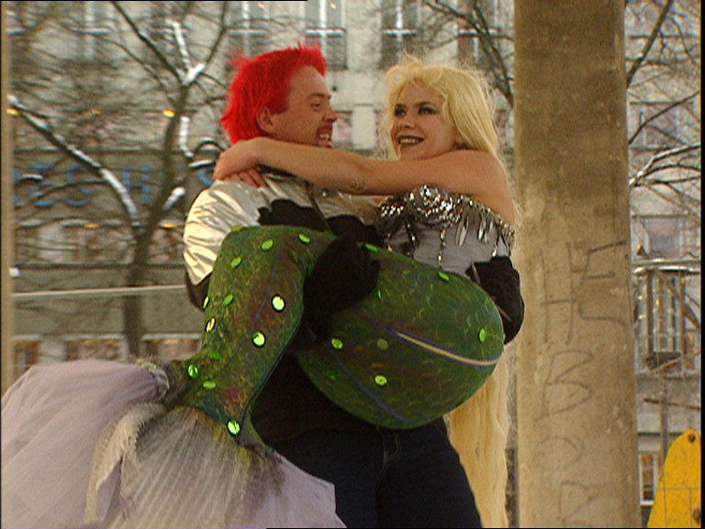

The original plan was to become involved early in the production process, and this status report would then be the basis for the work. However, the project started later than planned, and an alternative strategy was proposed. This is being carried out at the time of writing. We are working on the manuscripts and making amendments to Sol’s voice, and to the film sound. NRK TV expertise will then review the proposed changes and a final version will be completed. Together with this status report, the manuscripts will then be given to those responsible for sound editing, as a basis to produce a series with embedded described video.

# References

[1] Project web pages for the Embedded described video project:

<http://www.medialt.no/en-US/embedded-audio-description/1294.aspx>

[2] Article about NRK starting audio subtitles:

<http://www.medialt.no/news/en-US/norwegian-broadcasting-corporation-starts-audio-subtitling/935.aspx>

[3] Synstolking på TV, delrapport i FRES-prosjektet   
(AD of TV, project The Future of AD):

<http://www.medialt.no/dokumenter/1193.aspx>

[4] Fritt fram for Asgeir (electronic video book):

<http://www.medialt.no/product/barn/fritt-fram-for-asgeir/5/5010.aspx>

[5] Web page for the project Film between the ears:

<http://www.medialt.no/en-US/film-between-the-ears-film/720.aspx>

[6] About AMI:

<http://www.ami.ca/about/Pages/default.aspx>

[7] Embedded described video:

<http://www.acb.org/adp/edv.html>

[8] The AMI original series “Accessibility in Action”:

<http://www.ami.ca/AMI-tv/Pages/Accessibility-in-Action.aspx>

[9] The AMI original mini-series, “Milestones of Champions – the Journeys of Canada’s Paralympians”:

<http://www.ami.ca/AMI-tv/Pages/Milestones-of-Champions-Summer.aspx>

[10] A full list of AMI-tv’s original programs

<http://www.ami.ca/AMI-tv/Pages/all-shows.aspx>

[11] Two examples of traditional audio description:

<http://www.ami.ca/ami-tv/pages/DVsample.aspx>

[12] Two examples of embedded audio description:

<http://www.ami.ca/ami-tv/pages/EDVsample.aspx>

[13] BBC article about the project Sound experiments to improve films for blind people:

[http://www.bbc.com/news/technology-31039043](http://www.bbc.com/news/technology-31039043%20)

[14] Perceptual evaluation of an audio film for visually impaired audiences

Mariana Lopez, The Cultures of the Digital Economy Research Institute (CoDE), Anglia Ruskin University, Cambridge,

[15] Summary of guidelines for AD:

<http://www.mediaaccess.org.au/practical-web-accessibility/media/audio-description-guidelines>

[16] Described Video Best Practices:

<http://www.ami.ca/media-accessibility/Pages/Described-Video-Best-Practices.aspx>